Assignment 4 – Savitha Balarajan

1.     List all customers and the products they ordered with the order date. (Inner join)**Tables used:** customers, orders, order_details, products**Output should have below columns:** companyname AS customer,orderid, productname,quantity,orderdate.

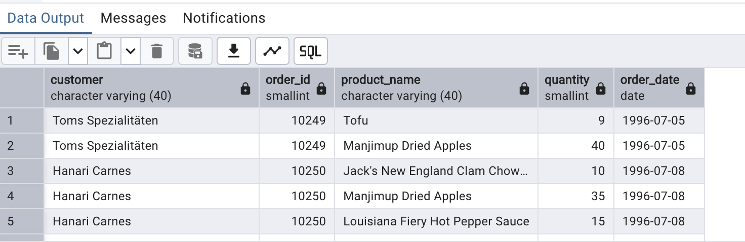

2.     Show each order with customer, employee, shipper, and product info — even if some parts are missing. (Left Join)**Tables used: orders, customers, employees, shippers, order_details, products.**

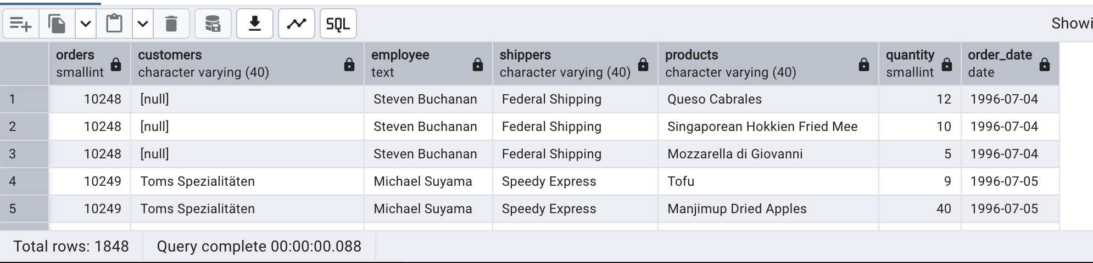

3.3.     Show all order details and products (include all products even if they were never ordered). (Right Join)**Tables used: order_details, products**

**Output should have below columns:** orderid, productid,quantity,productname

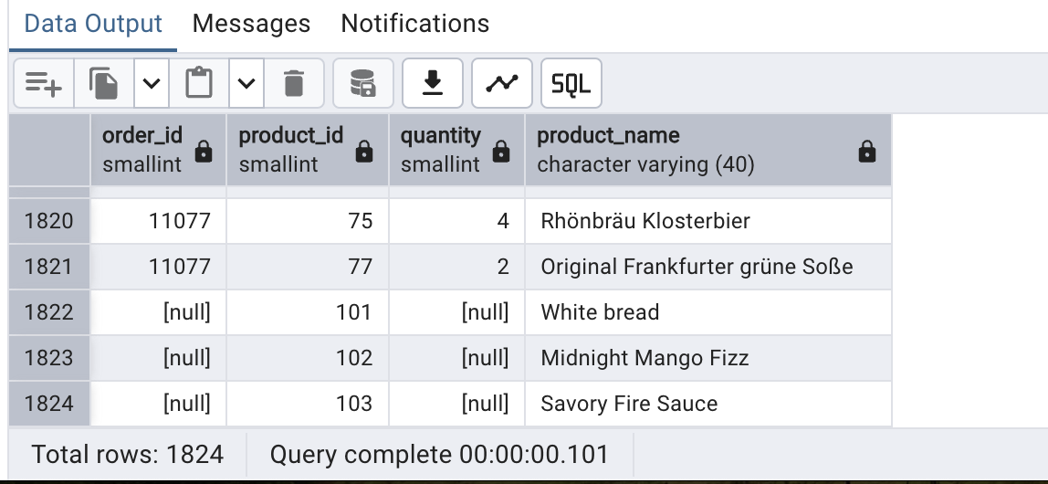

4. List all product categories and their products — including categories that have no products, and products that are not assigned to any category.(Outer Join)**Tables used: categories, products**

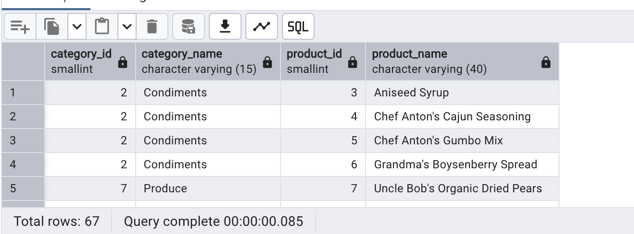

5. Show all possible product and category combinations (Cross join).

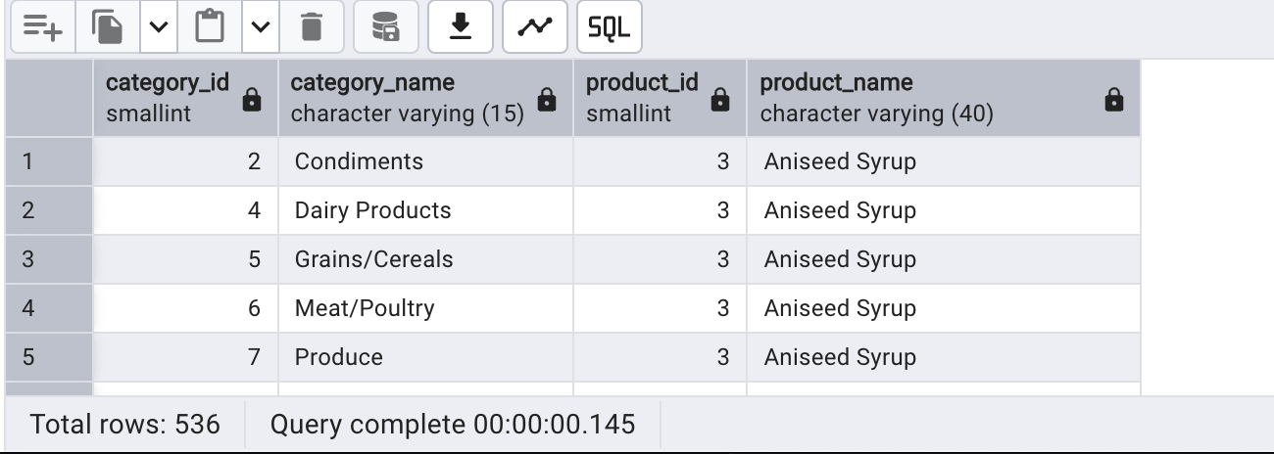

6. Show all employees and their manager(Self join(left join))

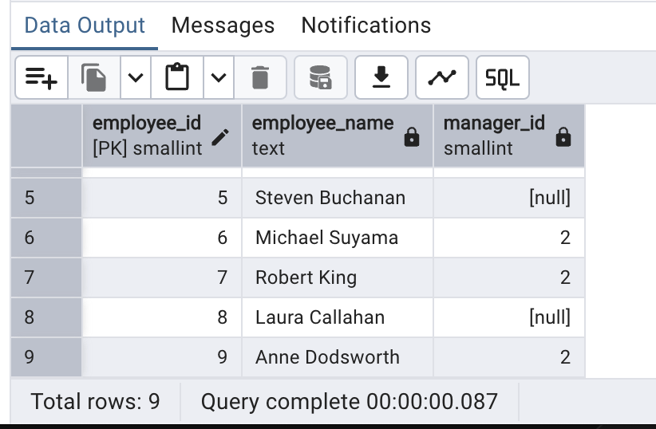

7. List all customers who have not selected a shipping method.**Tables used:** customers, orders**(Left Join, WHERE o.shipvia IS NULL)**

